Eric Suwarno
TEL: +62 812 6946 2204 | EMAIL: 121402071.es@gmail.com
About Me
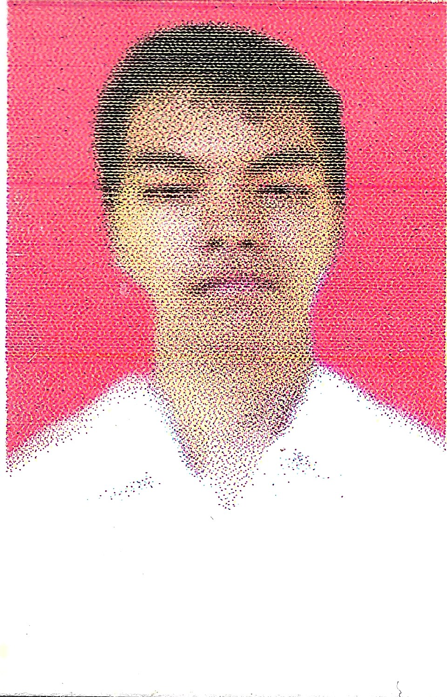
Birth Place and Birth Date : Pematangsiantar, 18 October 1994
Address : Jalan Cipto No. 14
Pematangsiantar, 21121
Gender : Male
Religion : Buddha
Status : Single
Education
- 2012 – 2017 : Faculty of Computer Science and Information Technology,
University of Sumatera Utara, Medan, Indonesia
- 2009 – 2012 : SMA Kristen Kalam Kudus, Pematangsiantar, Indonesia
- 2006 – 2009 : SMP Kristen Kalam Kudus, Pematangsiantar, Indonesia
Work Experience
- Laboratory Assistant in Information Technology Laboratory Group,
Faculty of Computer Science and Information Technology,
University of Sumatera Utara, Medan,
from October 2014 until January 2017
Job Description : Managing a practical laboratory class of classes taught by the lecturer. Be-fore the class is started, I have to coordinate every materials to be taught in the class with the lecturer, and then explaining the material to other students attending the class.
Special Skills
- Ability to learn every new knowledge quickly
- Ability to analyze the requirements of the project to be built
- Ability to code in Visual Basic, PHP, and C++

